Abstract
In this report I highlight the advantages of using digital active speaker cross-overs, as opposed to passive ones. To enable categorisation of cross-overs and speaker acoustic responses I improved the exponentially swept sine technique proposed by Angelo Farina. Specifically, the improvements allow better accuracy and phase measurement. I presented the detailed implementation workflow of the technique utilising PC card as digital-analogue interface. Adobe Audition is used for recording and Matlab for signal processing and results presentation.
I designed IIR and FIR digital cross-overs for an existing loudspeaker. Measurements confirmed that using active cross-over allows treating loudspeaker drivers simply as resistances, decoupling the system from mechanical parameters of the driver.
Acoustic tests show that a speaker driven by both IIR and FIR active cross-overs performs similarly to passive configuration; however power requirements of the amplifier can be reduced. A long FIR equalisation filter was shown to successfully flatten the acoustic response at high frequencies, which should result in more sonically accurate reproduction of sound.
Table of Contents
1 Abstract 1
2 Introduction 2
3 Frequency characterisation system 3
3.1 Signals used 3
3.2 Time domain response 5
3.3 Measurement workflow 6
4 Experimental results 7
4.1 Semi-octave smoothing 7
4.2 Sound card buffering 8
4.3 Amplitude 8
4.4 Phase 10
5 Digital cross-over design 12
5.1 Filter design 12
5.2 Design of a linear phase filter 15
5.3 Cross-over measurement results 15
5.4 Microphone connections and compensation 16
5.5 Acoustic measurements 17
6 Frequency response flattening 19
6.1 FIR filter design using Matlab 19
6.2 Extending the work 20
7 Conclusion 20
8 Appendix 21
8.1 Room impulse response model 21
8.2 Room equalisation 21
9 Works Cited 22

Introduction
Figure 2-1 shows a simplified diagram of a traditional audio reproduction system. It is widely used because of its simplicity. Also, if sound is stored on analogue media, such as vinyl or tape, there’s no need for D/A converter which makes the system even simpler. However such system has some disadvantages. A proportion of amplifier’s power is wasted in the passive components by flowing straight to the electrical ground. Speaker driver itself is a complex electromechanical system which couples driver inductance with the sprung diaphragm and the air around it. When connected to a passive cross-over network, extra poles are created and resultant frequency response can change. Passive cross-overs above order of 3 are rarely used, which limits them to simple filter shapes, and excludes possibility of compensating for a room’s acoustic response. I’ve shown a two-way speaker as an example (woofer for the base and tweeter for high frequencies). High-end loudspeakers can have up to 4 drivers, which makes passive cross-over design even more complicated and inefficient.
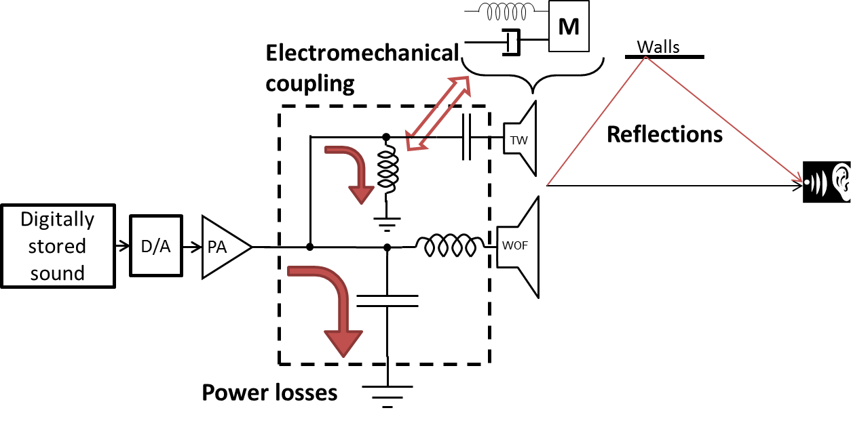  Figure 2-1 – passive cross-over | 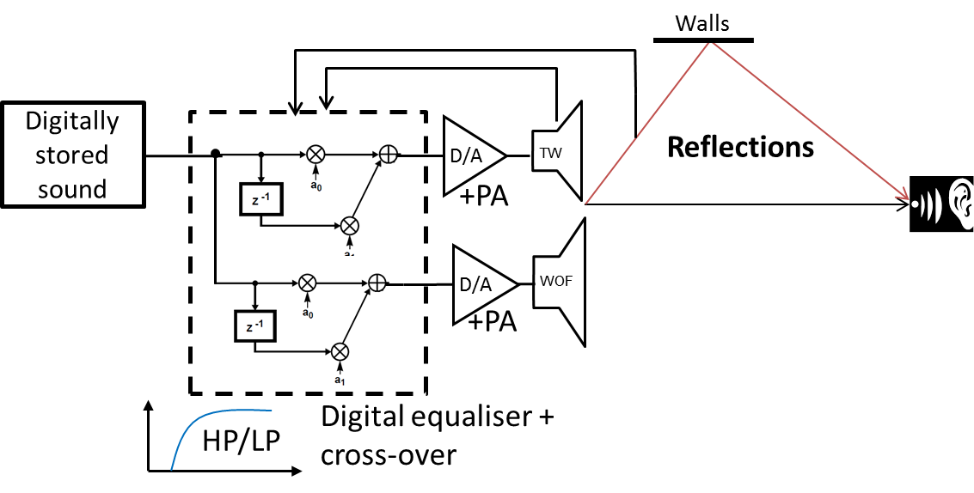  Figure 2-2 –active cross-over
Figure 2-2 shows an active cross-over configuration. We don’t need to convert digital sound into analogue before processing, which preserves original precision. Digital low and high pass filters are used to separate the signal, which is then amplified and fed directly into loudspeaker drivers. Compared with passive configuration, more amplifier channels are needed per every speaker – one per every driver. However amplifiers can be made smaller, as no power is wasted, and better optimised for the particular load they are driving. For example tweeter consumes a lot less power compared to woofer, so amplifier can be tailored to that.
Finally, digital filters can be made very flexible, to allow for correction of room’s acoustic response and speaker imperfections.
Of course, we have no knowledge of the room where the loudspeaker is going to be used, and loudspeakers themselves can be subject to manufacturing variations. Therefore I wanted to design a way to optimise digital filter based on the actual listening environment.
To summarise, active digital cross-over can provide two kinds of benefits – enhanced sound quality for the listener, and loudspeaker cost reduction through getting rid of costly passive components and simpler amplifier design.
The work I carried out in the beginning of the year on room acoustics modelling and equalisation did not yield good results, because the model did not take into the account several important phenomena of propagation of sound. That work is summarised in the appendix.

Frequency characterisation system

Signals used
To conduct electric and acoustic frequency response measurements I needed to develop characterisation technique. I had the following requirements for such a method:
- Must enable to measure frequency response over audible range 20-20,000Hz with good accuracy
- No special hardware required, only a standard PC and a sound card
We know that by definition impulse response of the system is output of the system when input is a delta function δ(t). That is:
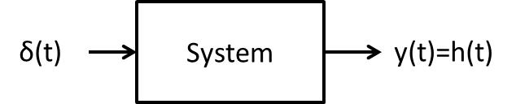
I will use the following notation throughout this report: all the time domain signals in lowercase, frequency domain signals in uppercase. The conversion is assumed to be FFT transform. For example, G(w)=fft(g(t)), and g(t)=ifft(G(w)).
Any signal x(t) can be represented as the same signal, x(t) convolved with δ(t), that is, convolution with delta function does not change the signal. Then we have:
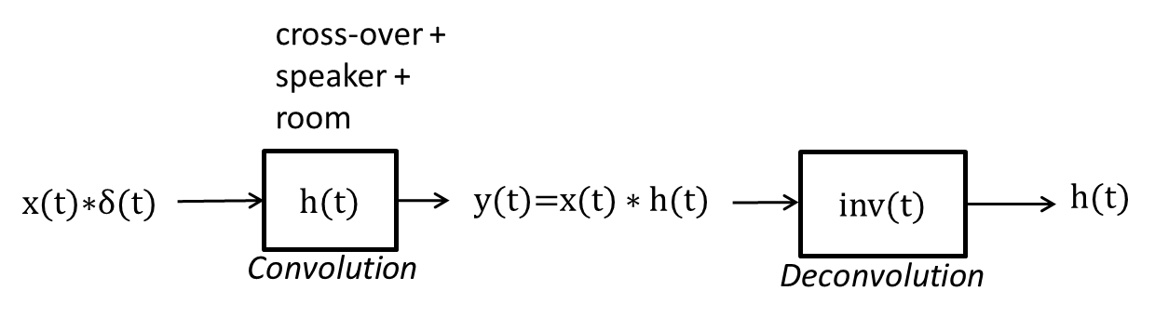
The Fourier transform of h(t) is H(w) which is what we need to find frequency response. Then, amplitude response is$\left|H(w)\right|$, and phase response is $∠H(w)$.
We could use any signal x(t) as long as it contains all the frequencies we’re interested in, and can be inverted to produce inv(t) such that $x\left(t\right)*inv\left(t\right)=δ(t)$. Such signal could be white noise, linear sine sweep, MLS or indeed a delta function.
Some methods do use delta function for acoustics measurements. A delta function can be approximated by sudden sharp noise such as gunshot, balloon pop or an electric spark. The advantage is that we obtain the impulse response by directly measuring the output. The downside of such method is that delta function contains only a small amount of energy in each frequency band compared to residual noise, which makes SNR of the measurement quite poor.
Exponential swept sine method popularised by Angelo Farina [1] fitted all the requirements, and has a number of advantages. I will describe the method in more detail.
The reason to use exponentially swept sine (ESS) is that we can get separate linear and harmonic impulse responses. This is illustrated in the spectrogram of a signal recorded with ESS technique, shown in Figure 3-1 a). Y axis is in log scale. Thick black line is the linear signal, and lines above are harmonics. We can see that harmonics with the same frequency as the linear signal occur at different, well-defined times. The resultant impulse response is shown in Figure 3-1 b), where impulse response of each harmonic is separated in time (note that linear response on the right of the figure goes off the scale).
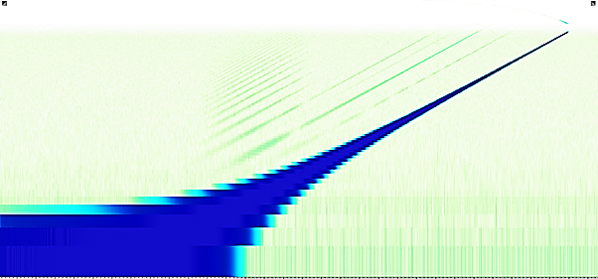  Frequency, Hz  Time, s  Second harmonic  First harmonic  Linear response  a).  Figure 3-1 - spectrogram of signal recorded with ESS method, and resulting impulse response | 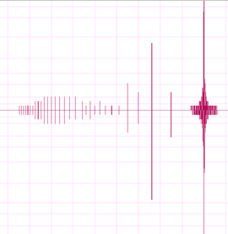  b).
This means that apart from measuring linear H(w) we can measure amplitude of each harmonic up to very high order in a single measurement. I have not used this property of ESS in my work, however if I wish to calculate harmonic distortion at a later stage, I do not need to take the measurements again.
The mathematical expression for ESS [1] is
$$x\left(t\right)=\sin\left(K\left(e^{\frac{t}{L}}-1\right)\right)$$ | (1)
Therefore we can express angular frequency w as a function of t
$$w\left(t\right)=\frac{d}{dt}\left(K\left(e^{\frac{t}{L}}-1\right)\right)$$
We can calculate parameters K and L based on the desired properties of swept signal: T=duration (seconds), w₁=2πf₁, w₂=2πf_{2.} Then,
K $=\frac{T{∙w}_{1}}{ln⁡\left(\frac{w_{2}}{w_{1}}\right)}$ and $L=\frac{T}{ln⁡\left(\frac{w_{2}}{w_{1}}\right)⁡}$
The final expression for instantaneous frequency as a function of time:
$$w\left(t\right)=w_{1}e^{\frac{t}{T}ln⁡⁡\left(\frac{w_{2}}{w_{1}}\right)}$$
I will now describe actual realisation of the ESS measurement method.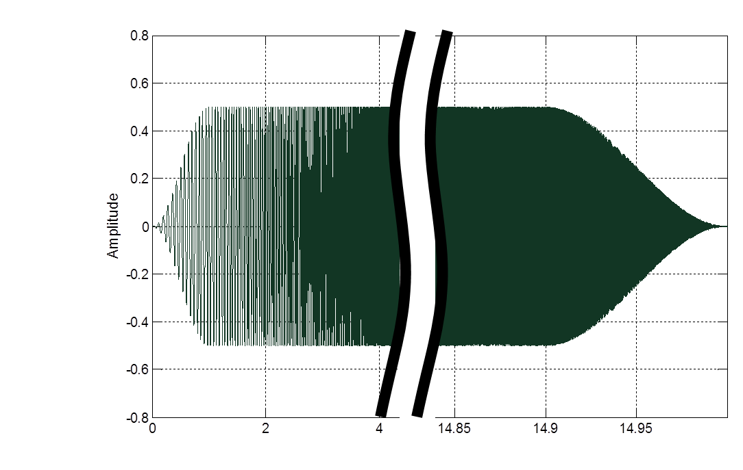
Time, s
f₁=11 Hz
f₂=22 kHz
Length =15s
Figure 3-2 – ESS signal features
The ESS signal is shown in Figure 3-2. The inverse signal inv(t) is obtained by time-reversing this signal, and applying -6dB per octave amplitude scaling to compensate for smaller energy at high frequencies in the ESS signal.
I created the ESS signal in Matlab as per (1). I got the idea to apply Hamming windows to beginning and the end of the signal from Angelo Farina’s plugin for Audition [2]. This is used to reduce frequency ripple near the start and end frequencies when calculating amplitude response. At first, I simply convolved x(t) and inv(t), to see how accurately inverse signal convolved with x(t) reproduced delta function (flat frequency spectrum). The frequency response is obtained as$H(w)=F\left\{x(t)\right\}×F\left\{inv(t)\right\}$, where $F$ is Fourier (FFT) transform.
Using 0.1 second windows, there was about 0.5dB ripple near the lower end. I extended start window to 1 second and lowered starting frequency to 11 Hz, which reduced the ripple to about 0.05dB, as shown in Figure 3-3.
Figure 3-3 - inverse signal amplitude response
I tried calculating inverse signal directly in frequency domain as $INV\left(w\right)=\frac{1}{X(w)}$ . The resultant frequency response is calculated simply as$X\left(w\right)×INV\left(w\right)$. It is shown in Figure 3-4. The amplitude response is perfectly flat. Additionally, as described in section 4.4, using this form of inverse signal allowed me to measure phase accurately, which is not possible with the original inv(t).
From this point onwards I will refer to inversion signal obtained by division in frequency domain as INV(w), and time-reversed inverse signal as inv(t). The two signals are not the same, so $F${inv(t)}≠INV(w). The recorded signal at audio card input is referred to as y(t).
Figure 3-4 – improved inverse signal amplitude response

Time domain response
By experimenting with the two inverse signals further, I discovered that obtaining time domain impulse is possible with time-reversed inv(t) signal, but is not possible with INV(w) signal.
Figure 3-5 shows the result of convolution y(t)$*$inv(t). As expected, we see the main linear impulse and harmonic responses preceding it.

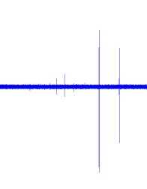  Figure 3-5 - time domain impulse response with harmonics – inv(t)$*$y(t) | Figure 3-6 - time domain - $F^{-1}\left\{INV(w) ×Y(w)\right\}$

Using INV(w) does not produce the expected result. As shown later in section 4.4, the sound card introduces constant delay at all frequencies. In this case output y(t) should equal to delayed version of input x(t), $y\left(t\right)=x\left(t-T\right)$. The Fourier transform of y(t) is equal to $X\left(w\right)e^{-jwT}$. As defined above, $X\left(w\right)×INV\left(w\right)=1$. Then
$$Y\left(w\right)×INV\left(w\right)=\left(X\left(w\right)×e^{-jwT}\right)×INV\left(w\right)=1×e^{-jwT}\underset{⇔}{}δ(t-T)$$
In other words, if input and inverse signal convolve into a delta function, time delayed input and inverse signal should convolve into a delayed delta function.
However in my experiments, INV(w)*Y(w) in time domain is not a delayed delta function but noise, shown in Figure 3-6. The explanation for this could be slight non-linearity in phase response of the audio card and noise introduced into y(t) during recording.
Therefore, the two different inversion signals should be used for different purposes. INV(w) should be used for precise amplitude and phase response measurements. inv(t) should be used to obtain impulse response in time domain, to extract harmonic distortion values.
In all of my experiments I kept harmonics amplitudes to the minimum. Harmonics were a lot higher if sound card recording level was above -3dB, close to saturation, so I made sure signal level stayed below that. As a result, harmonics levels were more than 50dB below the fundamental and I did not have to filter them out of the response.
Thus, I only used INV(w) in all of my experiments, as I did not have to examine time-domain response for harmonics.

Measurement workflow
The signal names I used in Matlab are described below. Frequency domain signals have names in capitals.
xt: exponentially swept sine signal, appended with 10 seconds silence
yt: output of the system under test, recorded in Adobe Audition
INV: inverse signal in frequency domain, such as INV.*XT=1
Hw: complex frequency response of the system
NFFT: size of xt in samples
- Set up Adobe Audition for recording and playback at 96KHz
- Playback xt while simultaneously recording the Mic input. Make sure recording level does not exceed -3dB to prevent harmonic distortion.
- Save the recording as a wave file
Switch to Matlab
- Import wave file into Matlab as yt
- Truncate or pad yt with zeros, to make it the same length as xt
- Obtain Hw=fft(yt).*INV;
- Keep only the positive frequencies from Hw: Hw=Hw(1:NFFT/2)
Then…
To extract amplitude response | To extract phase response
- Smooth magnitude of Hw in semi-octave intervals and create new results vector⁽²⁾  - Normalise to 0dB (or other value)  - Plot the results | - Find phase as the angle of the vector Hw  - Unwrap phase  - Subtract reference phase⁽¹⁾  - Interpolate onto semi-logarithmic scale  - Plot the results
⁽¹⁾ – To obtain reference phase, execute the process described above when signal yt is recorded with buffered output of the sound card fed directly to the buffered input, and save the result as a separate variable ref_phase
⁽²⁾ – Semi-octave smoothing is discussed in more detail in section 4.1.
It must be noted that vector Hw will contain frequency response information up to half the sampling rate, 48 kHz. However because ESS signal only goes up to 22 kHz, any frequency information above that is just noise. It is ignored from calculations and is not displayed.
When I first implemented the method, I normalised Hw to 1 after calculating it. Eventually I realised that doing so caused precision issues, as very small values of magnitude, when divided by the largest value in the vector then became comparable to numerical resolution of Matlab variables. This caused visible numerical round-off noise in parts of the spectrum with small magnitudes. I solved the problem by only normalising to 0 dB once logarithmic values had been obtained.

Experimental results

Semi-octave smoothing
Displaying frequency response plots with original number of points (1.2 million) is unnecessarily slow. I implemented a way to smooth the data based on semi-octave intervals. One octave is doubling of the frequency:${f_{1}=f}_{0}×2≈f_{0}×{10}^{0.3}$. One octave is too large of an increment to display meaningful data. 1/24 or 1/48th of an octave (multiples of 3) are typically used. For example, increments of 1/48th octave are${ f_{0}×10}^{\frac{0.3}{48}×N}$, where N is number of frequency increments. I used 1/96th octave smoothing. I calculated the number of frequency points as shown:
$22000={22×10}^{\frac{0.3}{96}×N}$, N=?
${10}^{\frac{0.3}{96}×N}=\frac{22000}{22}=1000$, taking log of both sides
$N=\frac{96}{0.3}log⁡(1000)$, N=960
Then the vector FREQ_SEMI_OCT is calculated as${ {FREQ_SEMI_OCT (N)=f}_{0}×10}^{\frac{0.3}{96}×N-1}$ for N=1…960
To obtain smoothed response, I summed all the values falling between two adjacent semi-octave frequencies from the raw magnitude response data, and divided them by number or samples to obtain average value.
Resulting data retained enough resolution for further calculations, but did not have frequency noise and was a lot quicker to plot and process.

Sound card buffering
I used SoundBlaster Audigy 2 sound card for signal playback and recording. Line Input could not be used as it feeds directly back to Line out, which results in oscillation. The impedance of Mic Input is quite low compared to the impedance of the circuits I was measuring, which skewed the measurements. I used op-amp buffers shown in Figure 4-1 to buffer the circuit under test. Alkaline 9V batteries are used as a power source, with 100nF and 10uF capacitors for decoupling.
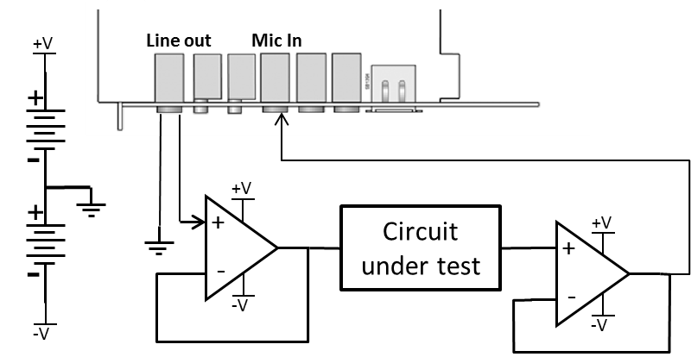  Figure 4-1 - sound card buffering schematic | 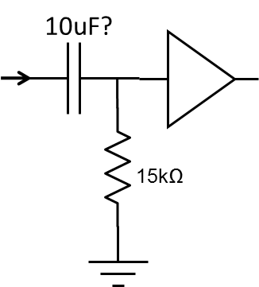  Figure 4-2 - Approximate Mic Input circuitry

Amplitude
First, I measured the amplitude response of the audio card, shown inverted in the red graph in Figure 3-3. We can see it has up to 1dB variations across the audio band. The measured response of the op-amp buffer is shown in the green graph. After subtracting audio card response we get true buffer response, shown in the blue graph.
In further experiments, I subtracted the buffer response to obtain true circuit response.
Figure 4-3 - sound card response compensation
I assembled a few simple test circuits on a breadboard to verify that characterisation method is valid. The 3 circuits I used are shown in Table 1. I used Matlab to simulate the response of these circuits.
Table 1
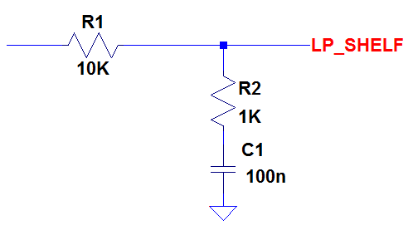 | 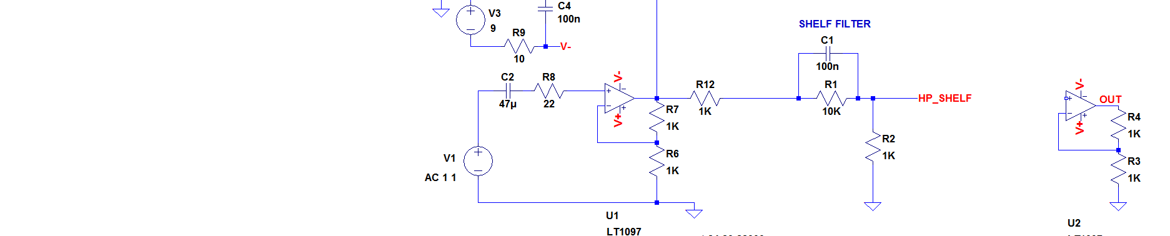 | 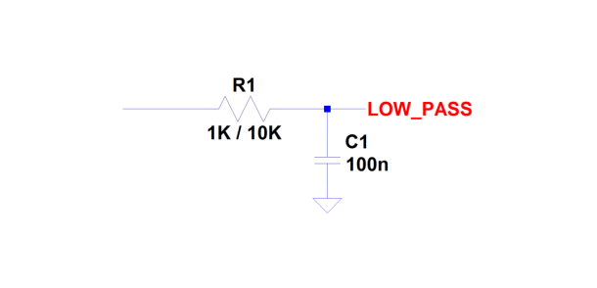
$$H\left(s\right)=\frac{{sC}_{1}R_{2}+1}{{sC}_{1}\left({R_{1}+R}_{2}\right)+1}$$ | $$H\left(s\right)=\frac{{sC}_{1}{R_{1}R}_{2}+R_{2}}{{sC}_{1}{R_{1}R}_{2}+(R_{1}+R_{2})}$$ | $$H\left(s\right)=\frac{1}{sC_{1}R_{1}+1}$$
Num=[C1*R2 1]  Den=[C1*(R1+R2) 1] | Num=[C1*R1*R2 R2]  Den=[C1*R1*R2 R1+R2] | Num=[1]  Den=[C1*R1 1]
Figure 4-4 shows measured and calculated amplitude responses for a low-pass shelf filter. We can see they agree perfectly.
Figure 4-4 – low pass shelf filter amplitude response
Figure 4-5 shows response of high-pass shelf filter and low-pass filters with different time constants. Again, measurements closely agree with calculated data.

× Calculated
LP, τ=1E-3
LP, τ=1E-4
HP shelf
Figure 4-5 - amplitude responses of sample circuits

Phase
Whereas calculating amplitude response from experimental data was quite straightforward, extracting phase response was more difficult. I used 3 methods of calculating phase.
- Using inv(t) + angle of complex frequency response H(w)
The phase data in this case seemed almost random, and I could not get any meaningful phase information.
- Quadrature phase detection in time domain
The algorithm I used is described below. The aim is to find angle between y(t)-green and x(t)-blue signals.
- Two complete periods of signals under consideration is extracted from continuous x(t) and y(t)
- y(t) is multiplied by x(t) and 90° shifted version of x(t), to form I (in-phase) and Q (quadrature components)
- Bounding indexes of integer number of periods are calculated. This improves accuracy.
- DC (mean) values of I and Q are calculated
- Phase shift $φ$ is calculated as atan of ratio of DC values
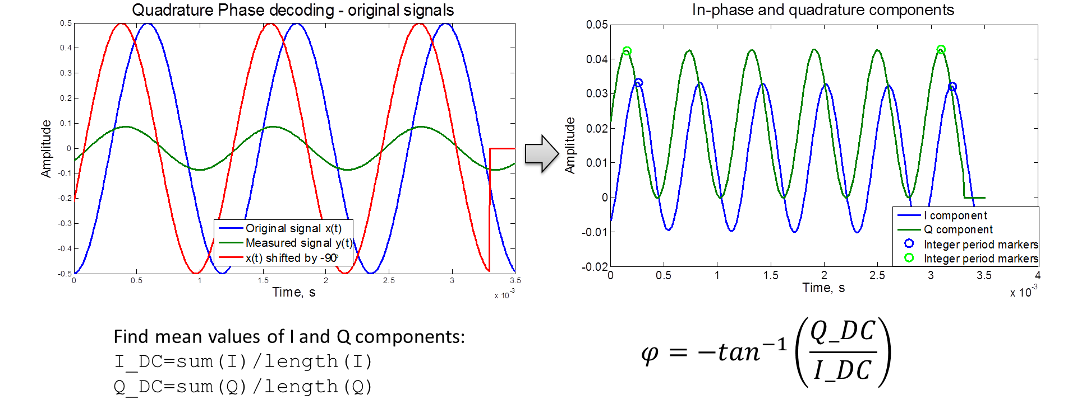
I got somewhat more encouraging results using this method, as shown in Figure 4-6.
Figure 4-6 - phase response of a shelf filter obtained with Quadrature Phase detector
Still, the results in Figure 4-6 are far from accurate, and deteriorate completely after 5 KHz. So I looked for a better method.
- INV(w) + angle of complex frequency response H(w)
I was able to get accurate phase information with this method. Figure 4-7 shows the measured unwrapped phase response of the audio card, input connected directly to the output. We can see it is a perfectly straight line, which suggests audio card introduces constant delay at all frequencies. From the graph I got a reading of 1060 radians phase shift at 22 KHz. Then, the delay is $\frac{φ}{ω}=\frac{1060rad}{22E3}=0.0077s$, or 736 samples. This value does not correspond to the buffer size or “latency compensation” values I set in the audio card driver settings. Also, this delay value changed every time I restarted computer or Adobe Audition, perhaps because of the way Windows handles audio buffers. This means that for accurate phase information, sound card calibration must be performed before a set of measurements is conducted.
In a recording system with deterministic delay between output and the input calibration can be avoided.

Figure 4-7 - phase response of audio card, obtained using INV(w) inverse filter
Figure 4-8 shows the phase response measured for sample circuits listen in Table 1. The shape of the response is captured correctly across the entire frequency range. However, absolute phase is only measured correctly if phase shift at the beginning frequency (22 Hz) is zero. Because of sound card phase compensation, the method is unable to resolve the absolute “starting” phase. This limitation could be resolved in future by either more elaborate phase calibration algorithm, or using recording system with deterministic recording delay.
× Calculated
LP, τ=1E-3
LP, τ=1E-4
HP shelf
Figure 4-8 – phase response of sample circuits obtained using INV(w) inverse filter

Digital cross-over design

Filter design
I obtained the schematic of the passive cross-over from the speaker manufacturer. Schematic diagram is shown in Figure 5-1.
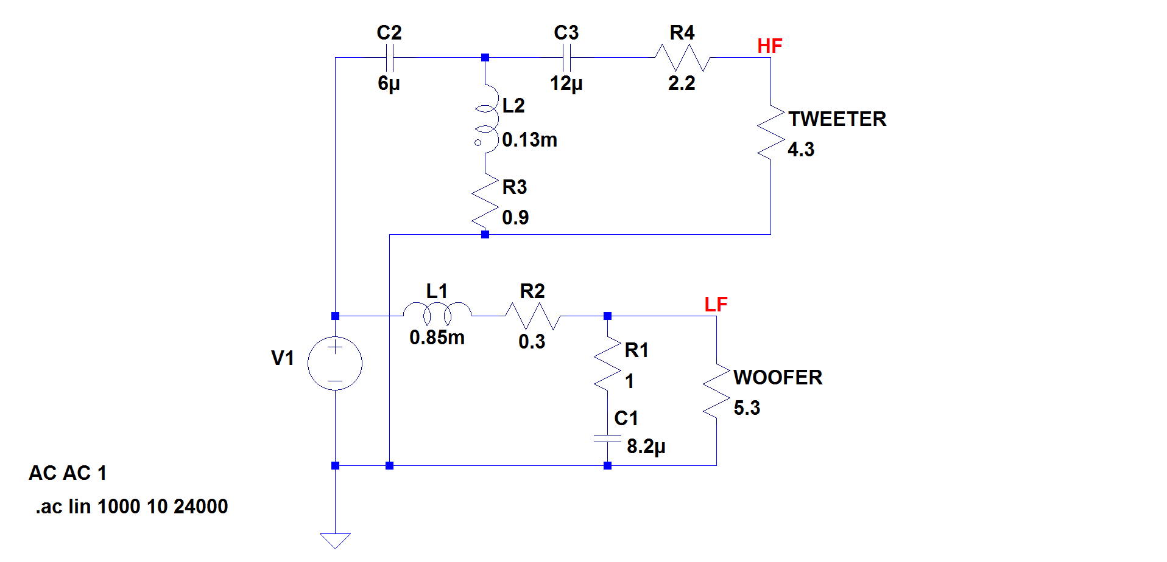
Figure 5-1 - passive cross-over schematic
I assumed driver impedances to be their DC resistances, which I measured. In reality, drivers are coils of wire, so they exhibit inductive behaviour. However I assumed that by using active cross-over I can treat them as resistances which proved to be true, as shown later.
I converted the second-order low pass section to s-domain equation by hand. For third order high-pass section I used Maple software to help me simplify the equation and collect the s terms.
The resultant equations are: $H_{LP}\left(s\right)=\frac{s\left(R_{w}C_{1}R_{1}\right)+R_{w}}{s^{2}\left(R_{w}L_{1}C_{1}+C_{1}R_{1}L_{1}\right)+s\left(R_{w}C_{1}R_{1}+L_{1}+0.3R_{w}C_{1}R_{1}+0.3C_{1}\right)+{(R}_{w}+0.3)}$ for the woofer, where R_{w} is resistance of the woofer coil.
$H_{HP}\left(s\right)=\frac{s^{3}\left(4.3L_{2}C_{2}C_{3}\right)+s^{2}(3.87C_{2}C_{3})}{s^{3}\left(6.5{L_{2}C}_{2}C_{3}\right)+s^{2}\left({L_{2}C}_{3}+{L_{2}C}_{2}+5.85C_{2}^{2}\right)+s(7.4C_{3}+0.9C_{2})}$ for the tweeter.

Because this process is cumbersome and required specialist maths knowledge, I decided to investigate alternative way of converting existing circuit to s-domain equation. Matlab has invfreqs command, which can calculate s-domain approximation given amplitude and phase response data. Obtaining this data would require measuring the cross-over circuits’ frequency response first.
Correct model approximation by invfreqs requires careful amplitude scaling, and did not always produce correct results, therefore I decided to use the manual method.
Figure 5-2 - impulse response of the low-pass digital filter | Figure 5-3 - impulse response of high-pass digital filter

I used bilinear transformation to convert s-plane polynomials H(s) to z-domain. The transformation approximates s as $\frac{2}{∆T}\frac{z-1}{z+1}$, where ∆T is the sampling interval.
bilinear command in Matlab performs the transformation. It has an optional parameter to specify pre-wrapping. Wrapping is a phenomena arising from imperfect mapping of s-plane to z-plane, and causes the frequency response to diverge from desired shape at frequencies close to Nyquist rate. The filters I designed only process signals up to 22 kHz, quite away from 48 kHz Nyquist rate of my system. Therefore wrapping was not an issue, and I omitted the pre-wrapping parameter.
I appended the shorter filter impulse response with zeros, to make them the same length, and stored both in a stereo wave file. I used a convolution plug-in [3] that works in any DirectX effect-enabled environment, like Adobe Audition.
I invoked the plug-in in Audition to convolve the stereo excitation signal x(t) with the stereo filter file. The process is illustrated in Figure 5-4. We can see that top signal (left channel) is high-pass filtered version of original x(t), and bottom signal (right channel) is low-pass filtered.
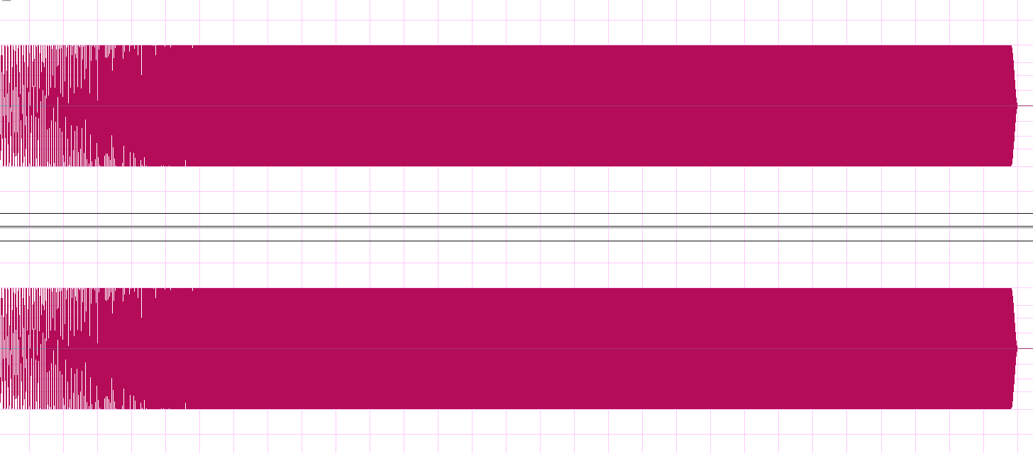  Figure 5-4 - convolving xt with cross-over digital filter | 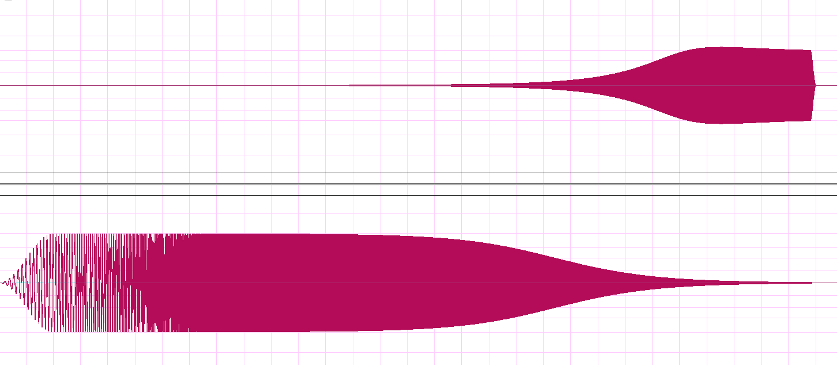
The stereo output of the sound card was then fed into the input of the power amplifier.
Figure 5-5 shows the wiring of the speaker that allowed me to switch between active and passive modes with just 2 switches, without any cable changes. Right channel is used to supply either all-pass signal or just the low frequencies in active mode. The power amplifier used is Creek Destiny Integrated analogue amplifier, capable of delivering 180Watts with 0.02% THD. For all purposes in this report I consider the amplifier as ideal voltage source with ≈0Ω output impedance.
To directly compare passive and active cross-overs, I measured high and low frequency signals directly at the input of the drivers, at points A and B shown in Figure 5-5. Results are discussed in section 5.3.
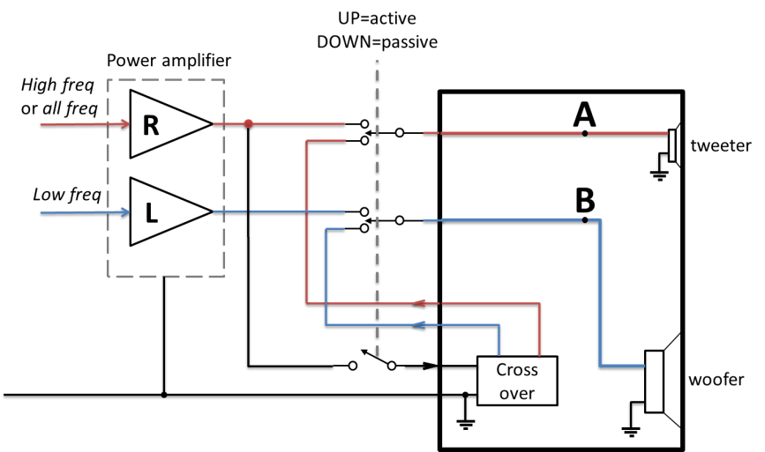
Figure 5-5 - speaker wiring

Design of a linear phase filter
The digital cross-over filter that I implemented so far is an IIR filter. It requires minimum number of taps for the required filter order, but inevitably has non-linear phase response. Why is linear phase important for audio applications? Filtering with non-linear phase will filter the signal correctly in frequency domain, but will distort the signal in time. All the frequency components will still be present in the correct proportion, but shifted relative to each other in time. Group delay larger than a certain value is perceived by the ear. The approximate thresholds of audibility are shown in Table 2 [4]. Simulation shows that group delay of IIR filters I implemented does not exceed 160us, far below the audible threshold.
Table 2
Frequency | Threshold
500 Hz | 3.2 ms
1 kHz | 2 ms
2 kHz | 1 ms
4 kHz | 1.5 ms
8 kHz | 2 ms
Still, I wanted to compare performance of completely linear phase (FIR) and IIR filters.
Matlab fir1 command performs design of standard FIR filters. The parameters of the filters are:
- Low pass: Cutoff frequency of 1200 Hz, 2nd order. Normalised frequency = 1200/48000=0.025
- High pass: Cutoff frequency of 4.5 kHz, 3rd order. Normalised frequency = 4500/48000=0.0938
To achieve required roll-off I empirically decided to set the order of digital low pass and high pass filters to 20 and 40, respectively:
lp=fir1(20,1200/48E3);
hp=fir1(40,4500/48E3,'high');
The acoustic performance of the speaker driven by this FIR cross-over filter compared to passive cross-over is discusses in section 5.5 below.
I did not measure the electrical performance of this filter, assuming it could be accurately simulated just like the IIR filter which I did measure.

Cross-over measurement results
Figure 5-6 shows measured electrical frequency response of the passive and digital cross-overs. We can see that the active cross-over produces identical frequency response to the calculated on the assumption of purely resistive load. On the other hand, passive components combined with drivers’ inductance introduce extra poles, which effectively add an order to the filters. This is not necessary bad, however it means we don’t get the response we’re designed for. A better model of the driver could include inductance, and passive cross-over can be designed accordingly. However, the “inductance” in this case will not be purely electrical; the coil is coupled to the diaphragm and the air around it. In one of the experiments (not shown) I held the speaker diaphragm still with my hand, and the electrical response was noticeably different. By using active cross-over we do not have to worry about such variables that we cannot always control.
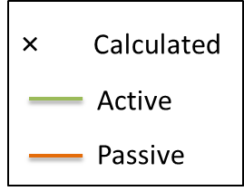
Figure 5-6 – active vs. passive cross-over electric characteristics
I conducted a simulation in LTSpice to estimate power loss in the passive cross-over. I used 1 second long ESS signal as an input, because it’s spectral density is similar to that of music. I integrated power drawn from the voltage source over time to find total energy drawn from the source. I integrated the power dissipated at the woofer and the tweeter, to find the total energy dissipated at the drivers, which is converted to useful sound. Then I calculated the loss in the cross-over as
$$Loss percentage=\frac{(total energy drawn)-(energy dissapated at the drivers)}{total energy drawn}×100\%$$
Using the values from the simulation, the loss percentage was estimated as 22% for this particular cross-over.

Microphone connections and compensation
To perform acoustic measurements I needed a microphone with a known frequency response. I used Behringer ECM8000, widely used by amateurs for room acoustics measurements. It is a condenser microphone and requires “phantom” power supply. I used PS400 supply to provide 48V DC and decouple sound signal from the DC voltage.
Figure 5-7 shows microphone connection to the PC. Balanced connection is required to minimise mains interference pickup.
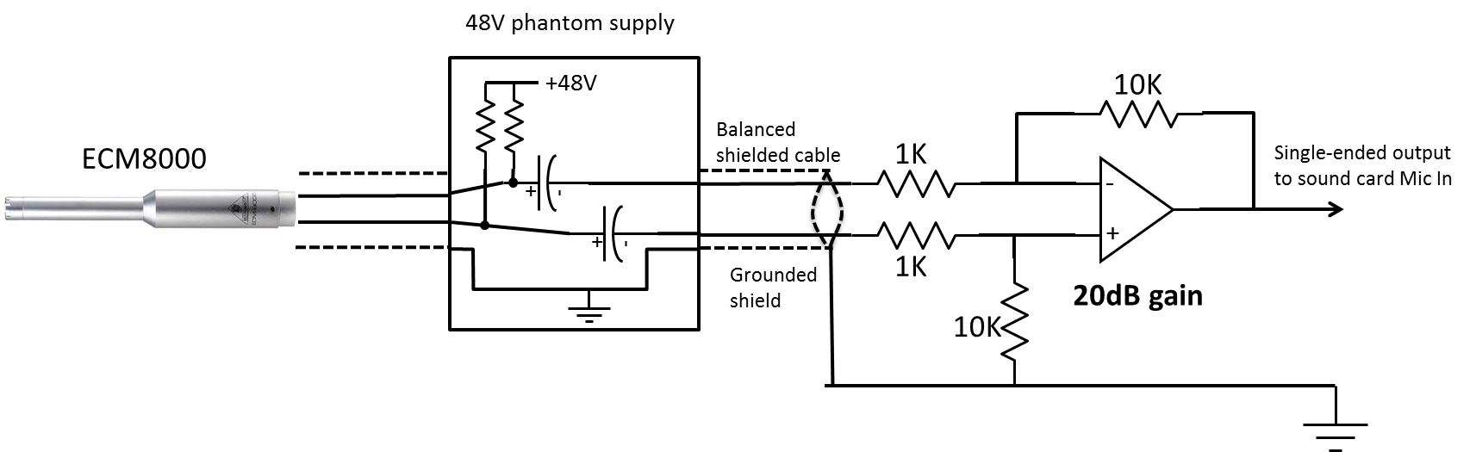
Figure 5-7 - microphone wiring
I used data shown in Figure 5-8 [5] to estimate frequency response of the microphone. I manually took values from the graph, and then interpolated them to the full frequency range using interp1 command.
I then applied the inverted response to spectrum of all the acoustic measurements I took.
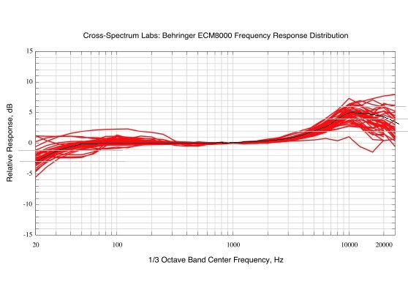
Figure 5-8 - ECM800 approximate frequency response
Despite shielded balanced connection, I recorded a significant level of noise on the sound card input (around -40dB) when the circuit was switched on, but with no test sound signal being played back. This noise is a combination of microphone’s inherent noise, mains interference, and sound of the computer fans picked up by the microphone. Analysing the spectrum of the noise revealed its power decreased by roughly 3dB every octave. Such noise is known as pink noise.
In future, best results can be obtained by using higher grade audio card with balanced input, and built-in phantom power supply. This way unshielded interconnects and ground loops can be kept to the minimum, preserving signal quality.

Acoustic measurements
First, I measured the acoustic response of woofer and tweeter separately, at distance 20cm away, on the centre axis of each driver. Results are shown in Figure 5-10. Low frequencies can damage tweeter by pulling the coil too far from neutral position, therefore I used starting frequency of 500Hz for tweeter measurements, and modified INV(w) accordingly.
As expected, tweeter response is low is lower frequencies, and then increases and stays relatively constant up to 20kHz. Woofer response is generally constant between 100Hz and 5kHz, then drops off.
I would like to implement an algorithm that could automatically design an active digital cross-over just based on this data. The algorithm would need to determine suitable cross-over frequency and roll-off rates (filter order) for each driver. Also, it should be able to work with loudspeakers with 3 and 4 separate drivers. Given the complexity of the data and the amount design experience needed, I was not able to implement the algorithm in time.
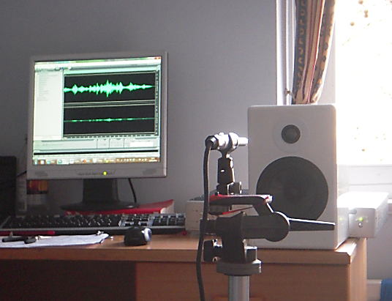
Figure 5-9 - recording set-up
Figure 5-10 - individual driver responses in active mode
Next I measured the response of the complete loudspeaker. I placed it on the edge of the table, facing into the room away from walls or any other large objects, to minimise acoustic reflections. Microphone was located 1m away from the speaker, on-axis with tweeter, which is the usual practice.
Figure 5-11 shows measured acoustic response with passive and active IIR cross-overs. We can see that responses are very similar, with the exception of active mode response having approximately 6dB dip in region between 2 and 4 kHz. The reason for that in not clear; however this dip can be easily corrected as shown in section 6.1.
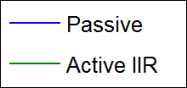
Figure 5-11 - loudspeaker response with passive vs. active IIR cross-overs

Figure 5-12 shows measured acoustic response with passive and active FIR linear phase cross-overs.
Figure 5-12 – loudspeaker response with passive vs. linear phase response cross-overs
Again, responses have almost identical shape, which means that FIR filter approximates the passive filter well. I conducted some subjective sound quality tests, which did not reveal any difference in the sound. Better assessment would require blind tests by people with good critical listening experience.
Additional experiments shown that the response does not change shape significantly if microphone is moved along the axis. This suggests that the measurement is a valid speaker measurement, not a measurement of the room excited by the speaker.

Frequency response flattening
I assumed that to hear sound as close to the original recording, audio spectrum produced by the loudspeaker at the ears’ location must be identical to the spectrum of the recording. This may not be necessarily true. Human hearing is complex and has different sensitivity to different frequencies. The recording may have been pre-processed already, to account for typical loudspeaker and room acoustics. In any case, I decided to investigate the possibility of making frequency response of the loudspeaker as flat as possible by just changing the cross-over, not the mechanical construction.

FIR filter design using Matlab

Here is the algorithm I used to design inverse FIR filter:
- Create linear frequency vector with range 0..Fs/2 (0..48kHz)
- Interpolate magnitude information from semi-octave frequency vector (22Hz-22kHz) onto linear frequency vector
- Negate magnitude vector values in dB, to obtain inverse magnitudes
- Pad low frequencies with constant attenuation value
- Convert magnitude from dB to absolute value: $A={10}^{\frac{dB}{20}}$
- Normalise linear frequency vector, so that largest value is 1
- Use fir2 command with desired number of taps to obtain filter coefficients b_{n}
- Obtain frequency response using freqz command
- Interpolate frequency response data back onto semi-octave frequency vector, to verify the response
The inverse filter I obtained using this method is shown in Figure 6-1. The length of the filter is 10000 taps. Inspecting the filter response it is evident that it approximates high frequencies a lot better than low frequencies.
Attenuation for frequencies below 280 Hz has been left constant. This frequency has been chosen empirically. Attempting to equalise low frequencies results in audio signal clipping and saturation of the speaker as the required gain is very large. Also, inverse filter does not approximate original response shape accurately at low frequencies, so instead of compensating specific features, only general attenuation is introduced.
Figure 6-1 - FIR inverse filter and resulting frequency response
We can see that the frequency response deviation in the band 1000 Hz – 22 kHz has been reduced from 15dB to under 10dB. Frequencies above 4 kHz have been flattened particularly well. Subjective listening tests with real samples of music confirm that equalised cross-over definitely sounds differently, with high frequencies audibly elevated. Whether it sounds good is a matter of personal preference.

Extending the work
I would like to extend the work I’ve done in a number of ways. So far, I’ve only worked with one loudspeaker. For a real listening set-up this would need to be extended to both left and right speakers, which can be done in a straightforward way. However equalising the sound at the position of the listener’s ears would be more complicated. A wearable wireless headset with a pair of microphones can be used to record test signal at exact listener’s position.

Conclusion
I successfully implemented exponentially swept sine technique for frequency response characterisation. I introduced some improvements that allowed me to accurately measure amplitude and phase response of electric circuits using a standard PC soundcard. Based on the technique acoustic measurements of the loudspeakers were performed using a suitable microphone.
I designed and measured digital cross-over filter for the existing loudspeaker. I demonstrated that speaker drivers, which normally exhibit complex electromechanical behaviour, can be treated simply as resistances when driven directly by the amplifier. The loudspeaker driven by both FIR and IIR versions of active cross-over was shown to have very similar acoustic response to that in passive configuration. However active-cross over can reduce power load on the amplifier by 22%.
Furthermore, FIR equalisation filter was shown to significantly flatten frequency response above 4 kHz.

Appendix

Room impulse response model
In the beginning of my project I concentrated on creating room acoustic simulation model. The most important feature of such simulation is to obtain an acoustic impulse response in a particular location given the positions and type of sound sources and dimensions of the room.
A few methods exist to approximate room acoustics. I used a ray tracing approach, where every ray object is given initial direction and amplitude, and then geometrically bounced around until it decays. The problem with such approach is that it does not account for diffraction around hard objects and diffuse reflections, which dominate low-frequency propagation. The model was implemented in Matlab. The details of implementation are presented in the second project report.
I came to conclusion that an accurate model would require far more time and expertise that I have. Also, I could just use a measured impulse response to go ahead with the main objective of my work – designing active digital cross-over and room equalisation.

Room equalisation
Analysing both simulated and real impulse responses we can see that in general they are mixed phase, meaning they have zeros outside unit circle. That means trying to invert them directly would produce a system with poles outside unit circle which is unstable.
There are a number of articles in literature describing various ways of approximating the inverse of non-minimum phase systems.
Notably, adaptive filtering is widely used for this purpose. I tried to use a LMS algorithm to create a stable inverse filter. For a sample of real music and non-minimum phase channel 120 samples long, the RMS error of equalisation was 1.5%. This is comparable to results presented in [6].
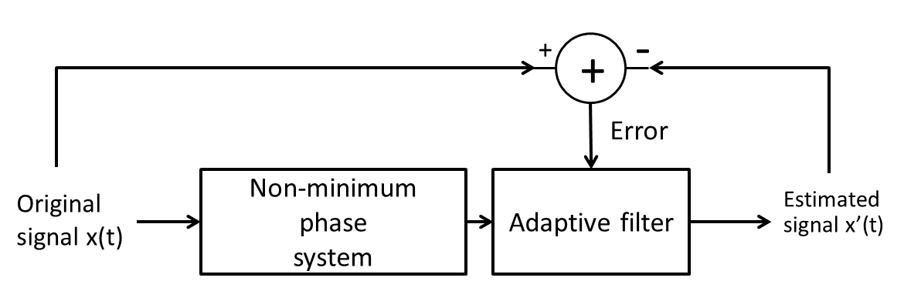
Figure 8-1 - adaptive filtering
I got somewhat encouraging results with LMS, but I decided to move on to active cross-overs and get back to LMS once the entire system was in place.

Works Cited

[1] | Angelo Farina, "Simultaneous measurement of impulse response and distortion with a swept-sine technique," Università di Parma, 2000.
[2] | Angelo Farina. http://www.aurora-plugins.com/.
[3] | Convolver — a convolution plug-in. http://convolver.sourceforge.net/.
[4] | J. and Laws, P Blauert, "Group Delay Distortions in Electroacoustical Systems," Journal of the Acoustical Society of America, vol. Volume 63, Number 5, pp. 1478-1483 (May 1978).
[5] | Cross-spectrum Labs. (2011, March) [Online]. http://www.cross-spectrum.com/measurement/calibrated_behringer.html
[6] | M. Lankarany and M.H. Savoji, "Deconvolution of Non-Minimum Phase FIR Systems using Adaptive Filtering," Shahid Beheshti University, Tehran,.
[7] | Madeline Carson et al, "SURROUND SOUND IMPULSE RESPONSE, Measurement with the Exponential Sine Sweep, Application in Convolution Reverb," UNIVERSITY OF VICTORIA, 2009.

